St John the Baptist - Autumn Matrix – Year 1 2025-2026
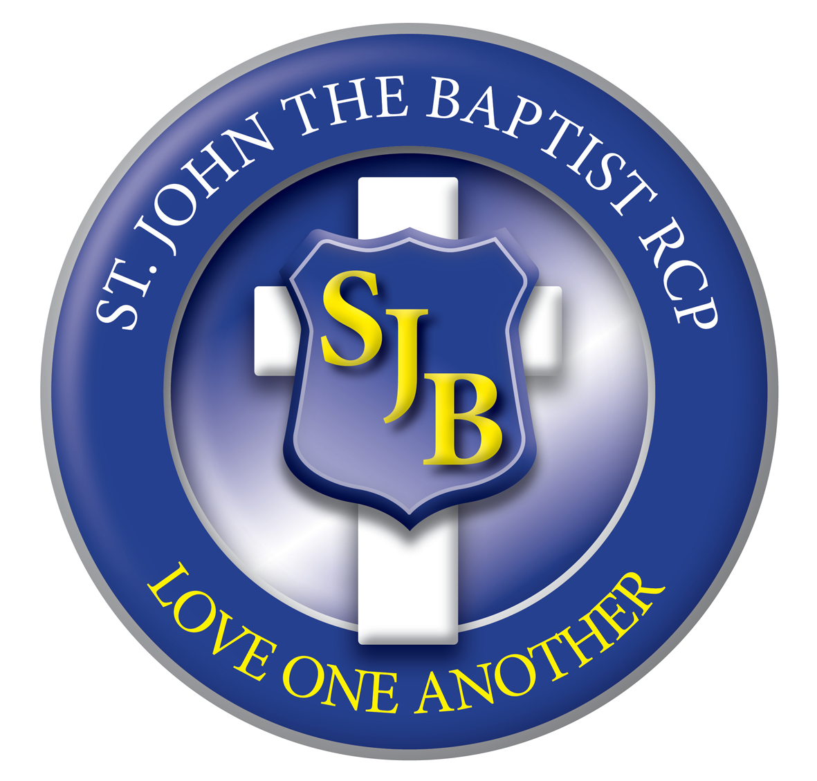

Autumn1  7wk 3days weeks  Autumn 2  7 weeks | 1  Inset  Mon 1st  Tue  2nd  Sept | 2  8th  Sept | 3  15th  Sept | 4  22nd Sept | 5  29th  Sept | 6  6th  Oct | 7  13th  Oct | 8  20th  Oct  4 days  Fri INSET | HALF TERM 21st – 25TH OCTOBER | 1  3rd  Nov | 2  10th  Nov | 3  17th  Nov | 4  24th  Nov | 5  1st  Dec | 6  8th  Dec | 7  15th  Dec Close on Fri 19th
Behaviour  Focus | ‘Love One Another’  BE A GOOD FRIEND |  |  |  |  |  |  |  |  | ‘Love One Another’  BE KIND AND LOVING
RE  LIGHTING THE PATH | MARIAN  BRANCH 1 CREATION AND COVENANT  ‘Why is it important to take care of the world God made?’ |  |  |  |  |  |  | THEME WEEK - | 27th -31st October | REMEMBRANCE  BRANCH2 PROPHECY AND PROMISE  ‘How does the story of Jesus’ birth show God’s love, and why are Mary and the Angels important?’
English  Texts | TRADITIONAL TALES  Jack and the Beanstalk  The Enormous Turnip |  |  |  |  |  |  | THEME WEEK - | 27th -31st October | STICKMAN
English  Grammarsaurus  Literacy Shed | Lists, captions and Labels  Non chronological reports- Jack and Beanstalk characters  Repetitive narrative- The Enormous Turnip |  |  |  |  |  |  | THEME WEEK - | 27th -31st October | Recount- Letter postcards-Stickman adventures  Narrative- character description- Santa  Poetry- Acrostic
Maths  INSPIRE | Number and Place Value  Numbers to 10, Number bonds, Addition and subtraction within 10. |  |  |  |  |  |  | THEME WEEK - | 27th -31st October | Shapes and patterns, ordinal numbers, numbers to 20, addition  and subtraction within 20.
Maths  INSPIRE | INSPIRE 1 - Unit 1,2,3,4 |  |  |  |  |  |  | THEME WEEK - | 27th -31st October | INSPIRE 1- Unit 5,6,7,8
Science  Switched on  Science | NC Programme of Study – Animals, including humans  Topic 1- Who am I? |  |  |  |  |  |  | THEME WEEK - | 27th -31st October | NC Programme of Study – Animals, including humans  Topic 2- Celebrations
History  Plan Bee |  |  |  |  |  |  |  | THEME WEEK - | 27th -31st October | NC Programme of Study – Britain after 1066  Topic- Toys- Past and present
Geography  Plan Bee | NC Programme of Study – Human Geography, Locational and place knowledge, physical geography  Topic- Where do I live? |  |  |  |  |  |  | THEME WEEK - | 27th -31st October
DT  Plan Bee |  |  |  |  |  |  |  | THEME WEEK - | 27th -31st October | NC Programme of Study – Mechanisms and mechanical systems  Topic- Moving picture
Art & Design  Plan Bee | NC Programme of Study – Nature Art  Topic- Earth Art |  |  |  |  |  |  | THEME WEEK - | 27th -31st October
Music  Charanga/  Wops | Hey You!  Old-school  hip-hop |  |  |  |  |  |  | THEME WEEK - | 27th -31st October | Christmas Songs  All children involved in learning and performing a whole  school presentation which includes singing, movement and dance
PE  LEA scheme | Baseline unit (FMS)  Create a sequence of travel, roll and jump safely using shapes.  To show two simple tactics in a game |  |  |  |  |  |  | THEME WEEK - | 27th -31st October | Dance (FMS) Combine dance sequences to retell aspects of a story.  To throw under arm using tactics
Computing  icompute | iAlgorithm |  |  |  |  |  |  | THEME WEEK - | 27th -31st October | iProgram
PSHE  One Decision | KEEPING/STAYING SAFE Tying Shoelaces  KEEPING/STAYING HEALTHY Washing Hands |  |  |  |  |  |  | THEME WEEK - | 27th -31st October | RELATIONSHIPS  Friendship Bullying

