St John the Baptist - Spring Matrix – Year 1 2025-2026
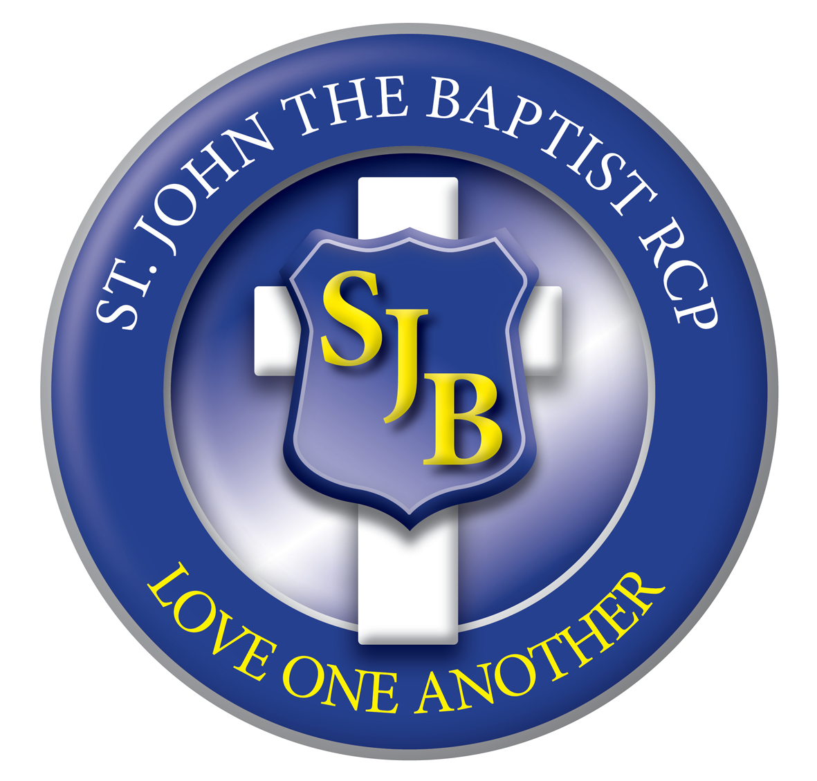

Spring 1  5wks 4 days  Spring 2  5 wks 4 days | 1  Tue 6th  Jan | 2  12th  Jan | 3  19th  Jan | 4  26th  Jan | 5  2nd  Feb | 6  9th  Feb Close  Fri 13th | HALF TERM | 1  23rd  Feb | 2  2nd  Mar | 3  9th  Mar | 4  16th  Mar | 5  23rd  Mar | 6  30th  Mar  Close Thur 2nd April
Behaviour  Focus | ‘Love One Another’  BE HELPFUL AND GIVING |  |  |  |  |  | 16th – 20th February | ‘Love One Another’  BE POLITE AND WELL MANNERED
RE  LIGHTING THE PATH | BRANCH 3  CANDLEMAS  Galilee to Jerusalem  Jesus is Special, Baptism, Sharing God’s Love |  |  |  |  |  | 16th – 20th February | BRANCH 4  LENTEN  Desert to Garden  Lent and Easter are special
English Text | Lost and Found |  |  |  |  |  | 16th – 20th February | WHAT THE LADYBIRD HEARD AT THE SEASIDE
English  Grammarsaurus  LITERACY SHED | Non chronological reports- Polar animals  Recount- Letter/postcards- Creature in a new place |  |  |  |  |  | 16th – 20th February | Persuasive advert- Come to Blackpool  Poetry- riddles
Maths  INSPIRE | Length, Mass, Picture Graphs |  |  |  |  |  | 16th – 20th February | Numbers to 40, mental calculations, multiplication
Maths  INSPIRE | INSPIRE 1: Unit 9,10,11 |  |  |  |  |  | 16th – 20th February | INSPIRE 1: Unit 12,13,14
Science  Switched on  Science | NC Programme of Study – Animals including humans, Everyday  materials  Topic 3 – Polar Places |  |  |  |  |  | 16th – 20th February | NC Programme of Study – Year 1 Habitats Topic 4- Plants and animals where we live
History  Plan Bee |  |  |  |  |  |  | 16th – 20th February | NC Programme of Study – Britain after 1066, The Victorian  Era  Topic- Seaside Holidays in the Past
Geography  Plan Bee | NC Programme of Study – Continents and countries, Human  geography, Physical geography  Topic- Around the World |  |  |  |  |  | 16th – 20th February
DT  Plan Bee |  |  |  |  |  |  | 16th – 20th February | NC Programme of Study – Cooking and nutrition, World  food day, World health day  Topic- Eat more fruit and vegetables
Art & Design  Plan Bee | NC Programme of Study – Biomes and Climate Zones  Earth Art |  |  |  |  |  | 16th – 20th February
Music  Charanga | In the Groove  Blues, Latin, Folk fusion |  |  |  |  |  | 16th – 20th February | Round and Round  Latin American Film Music
PE  Lancs Scheme | Gymnastics (FMS)  Catch a ball with some accuracy using tactics.  Create a sequence of travel, roll and jump using shapes and  apparatus |  |  |  |  |  | 16th – 20th February | Multi-Skills Games (FMS) Over arm throw with some  accuracy using tactics.  FMS—kicking a ball accurately.
Computing  icompute | iWrite |  |  |  |  |  |  | iData
PSHE  One Decision | BEING RESPONSIBLE  Practise makes perfect  Water Spillage |  |  |  |  |  |  | FEELINGS AND EMOTIONS  Jealousy  Worry

