St John the Baptist – Summer Matrix – YEAR 1 2025-2026
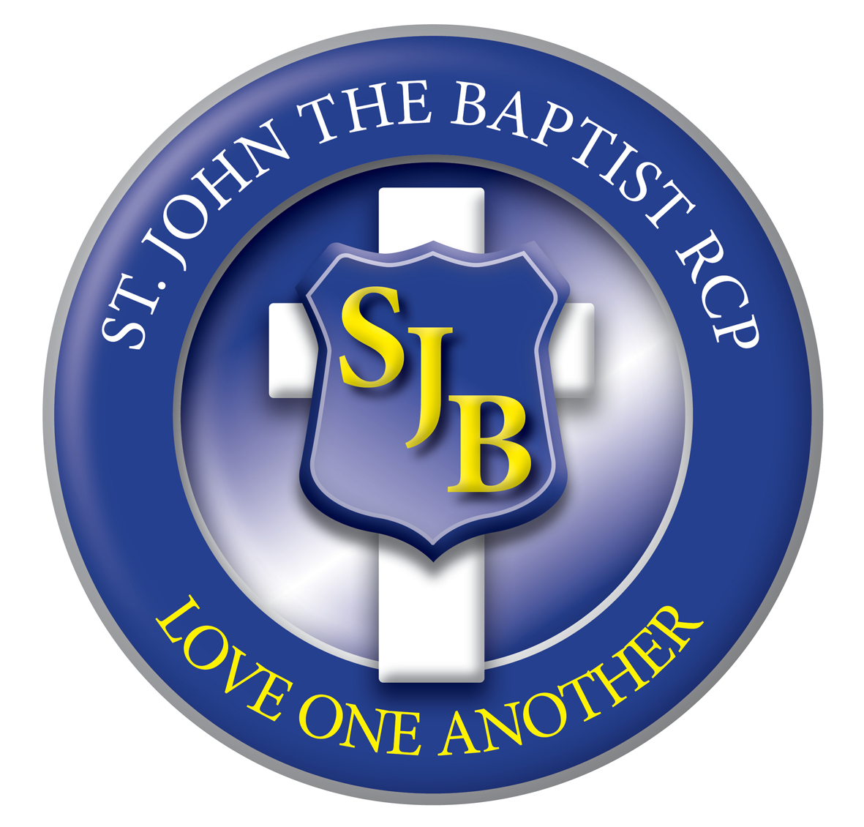

Summer 1  5 wks  Summer 2  7 wks | 1  20th  April | 2  27th  April | 3  5th May  Mon 4th Bank Hol | 4  11th  May | 5  18th  May | HALF TERM 25th – 29th May 2026 | 1  1st  June | 2  8th  June | 3  15th  June | 4  22nd  June FUN WEEK | 5  29th  June | 6  6th  July | 7  13th  July  Close Fri 17th July  INSET Mon 20th
Behaviour  Focus | ‘Love One Another’  BE FORGIVING |  |  |  |  | HALF TERM 25th – 29th May 2026 | ‘Love One Another’  BE A PEACEMAKER & BE TRUTHFUL
RE  LIGHTING THE PATH | BRANCH 5  PENTECOST  The Holy Spirit and prayer |  |  |  |  | HALF TERM 25th – 29th May 2026 | BRANCH 6  TRINITY  The Parish, Christians around the world, Judaism
English Text | The Very Last Castle, Castle Adventures |  |  |  |  | HALF TERM 25th – 29th May 2026 | Supertato
English  Grammarsaurus | Non-chronological report- Castles  Narrative- Setting description- Fairy Tale Castles |  |  |  |  | HALF TERM 25th – 29th May 2026 | Narrative-final  Instructions- How to defeat the dirty dishcloth
Maths  INSPIRE | Multiplication, Division, Time  INSPIRE 1: Unit 14,15,16 |  |  |  |  | HALF TERM 25th – 29th May 2026 | Numbers to 100, Getting to know money, Adding and subtracting  money  INSPIRE 1: Unit 17,18,19
Science  Switched on  Science | NC Programme of Study – Plants, Animals including humans,  Everyday materials  Topic 5- On Safari |  |  |  |  | HALF TERM 25th – 29th May 2026 | NC Programme of Study – Animals including humans, Everyday  materials  Topic 6 - Holiday
History  Plan Bee | NC Programme of Study – Britain after 1066, Art, Design and  Technology, Geography, History  Topic- Castles |  |  |  |  | HALF TERM 25th – 29th May 2026
Geography  Plan Bee |  |  |  |  |  | HALF TERM 25th – 29th May 2026 | NC Programme of Study – Weather and climate, Physical geography  Topic- The Four Seasons
DT  Plan Bee |  |  |  |  |  | HALF TERM 25th – 29th May 2026 | NC Programme of Study – Structures  Topic- Playgrounds
Art & Design  Plan Bee | Design and Technology, Geography, History  Topic- Castles |  |  |  |  | HALF TERM 25th – 29th May 2026
Music  Charanga | Your imagination  Pop music |  |  |  |  | HALF TERM 25th – 29th May 2026 | Reflect, Rewind,  Replay  History of Music
PE  Lancs Scheme | Athletics and Gymnastics  To jump, hop, roll a ball, run, change direction with  some control.  Create a sequence of travel, roll and jump using shapes  and apparatus. |  |  |  |  | HALF TERM 25th – 29th May 2026 | Dance (FMS)  Link dances together and perform as a class.  Perform rolls, bounce/roll a ball with accuracy.  To jump and land safely.
Computing  icompute | iSafe, E-Safety |  |  |  |  | HALF TERM 25th – 29th May 2026 | imodel
PSHE  One Decision | COMPUTER SAFETY  Online Bullying |  |  |  |  | HALF TERM 25th – 29th May 2026 | Money matters

